Optimization of Growth Media, Antibiofilm Evaluation, and Taxonomic Identification of Symbiotic Bacteria from the Sea Anemone Heteractis magnifica

Kania Salsabila¹, Ela Novianti^{2*}, and Syamsul Falah¹

¹Department of Biochemistry, Faculty of Mathematics and Natural Sciences, IPB University,
IPB Dramaga Campus, Bogor, West Java 16680, Indonesia
²Research Center for Genetic Engineering, National Research and Innovation Agency (BRIN), Jl. Raya Jakarta Bogor Km. 46, Bogor, West Java 16911, Indonesia

*Corresponding author: ela.novianti@brin.go.id

Abstract

Antibiotic resistance and biofilm-associated infections remain critical global health challenges. It’s responsible for up to 65% of infections in humans and has adaptive resistance 10–1000 times higher against conventional antibiotics. Thus, the development and finding of new antibiofilm agents is needed. Marine bacteria, particularly symbionts of anemone Heteractis magnifica, offer promising yet underexplored sources of bioactive componds as antibiofilm agents. This research aimed to optimize the growth conditions, assess the antibiofilm activities and identify potential strain of symbiotic bacteria from H. magnifica in Samalona Island, Indonesia. The growth of two bacterial isolates (CM01 and CM03) were optimized, revealing that CM01 grew best in TSB with 2% NaCl and 2% peptone at 37 °C for 48 h incubation, while CM03 exhibited optimal growth in Zobell medium with 2% peptone at 28 °C for 48 h. Secondary metabolites produced under these conditions were tested against Escherichia coli, Pseudomonas aeruginosa, Bacillus subtilis, Staphylococcus epidermidis, and Staphylococcus aureus. The 50-hour metabolite of CM03 demonstrated the strongest and broadest antibiofilm activity. Due to its antibiofilm potential, strain CM03 was subjected to genomic characterization using 16S rRNA PCR method. Phylogenetic analysis identified the isolate as Halalkalibacter okhensis. These findings indicate that symbiotic bacteria of H. magnifica, particularly H. okhensis CM03, represent promising candidates for the discovery of new antibiofilm agent.

Keywords: biofilm, growth optimization, Halalkalibacter okhensis, marine bacteria, secondary metabolites

Introduction

Bacteria are classified as resistant when their growth is no longer inhibited by the maximum clinically achievable concentrations of antibiotics. Antibiotic resistance has emerged as one of the global health challenges, driven largely by inappropriate antibiotic usage, including in Indonesia, where 53–62% of the population tends to stop consuming antibiotics once they feel better (Kong et al., 2021). This issue is further worsened by the limited availability of new antimicrobial agents. Additionally, bacteria that form biofilms present an even greater challenge, as they demonstrate a tolerance level of antibiotics up to 10–1000 times higher than planktonic cells due to the presence of physical barriers such as extracellular matrices, as well as complex physiological adaptations (Sharma et al., 2023). Biofilm-associated infections account for an estimated 65% of human infections and are often persistent, difficult to eradicate, and associated with high morbidity, especially in children and the elderly (Haney et al., 2018). Unfortunately, there is currently no specific therapeutic option targeting biofilm-producing pathogens, underscoring the urgent need to discover new bioactive compounds with potent antibiofilm activity.
The marine environment represents a vast and underexplored habitat of microbial diversity with high potential for novel bioactive compound discovery (Tortorella et al., 2018). Although the oceans cover more than 70% of the Earth's surface, only about 5% has been explored. Marine organisms have adapted to unique ecological conditions, such as high hydrostatic pressure, lack of light, and low nutrient availability, as well as limited oxygen, leading to the production of diverse and uncommon biologically active metabolites
compared with terrestrial organisms (Hassan & Jin, 2024). This makes marine-derived bacteria an attractive source for identifying new antimicrobial and antibiofilm agents.
Sea anemone, including the species Heteractis magnifica, harbor complex microbiomes composed of symbiotic bacteria that contributes to the production of secondary metabolites as a result of host defense mechanisms. Previous research has revealed the potential of antimicrobial, antitumor, antiviral, and antifungal properties from many marine invertebrates (Andryukov et al., 2019; Gavriilidou et al., 2020). Studies on exploring the potential of marine bacteria as antimicrobial agents have been conducted by Abdillah et al. (2024) and Böhringer et al. (2017) in several regions of Indonesia; however, the bacterial associated with H. magnifica remain insufficiently characterized, and their potential as producers of antibiofilm compounds is largely unexplored. Understanding the taxonomic identity of these symbiotic bacteria is crucial, as phylogenetic relationships often correlate with the types of secondary metabolites they can synthesize. Furthermore, optimizing growth media is essential for maximizing the production of bioactive metabolites, as the composition of nutrient and environmental conditions significantly influences bacterial metabolite profiles (Stanaszek-Tomal, 2020). Customizing culture media can increase bioactive compound production, thereby facilitating the detection and characterization of their antimicrobial or antibiofilm activities.
Considering these factors, investigating symbiotic bacteria associated with H. magnifica offers promising opportunities to identify novel antibiofilm-producing strains. This study seeks to optimize growth media for enhanced bacterial cultivation, evaluate the antibiofilm activity of the isolates, and conduct taxonomic identification to characterize the symbiotic bacteria associated with H. magnifica. The findings are expected to contribute to the discovery of new marine-derived antimicrobial agents and to expand knowledge of host-associated microbial diversity in marine ecosystems.

Materials and Methods

Bacterial culture. The bacterial samples associated with the H. magnifica anemone (CM01 and CM03) were collected from Samalona Island, South Sulawesi, Indonesia (5°07'27"S 119°20'37"E) in April 2024. The frozen isolates, stored at −80 °C, were reactivated by streaking onto Zobell Marine 2216 agar and incubating at 37 °C for 24 hours. A single colony was subsequently selected and inoculated into Zobell Marine 2216 broth, followed by incubation at 37 °C with shaking at 250 rpm for 24 hours.

Optimization of growth media and metabolite production. Growth media optimization was performed by evaluating several formulations: Tryptic Soy Broth (TSB) medium (1.7% pancreatic digest of casein, 0.3% peptic digest of soybean, 0.5% sodium chloride, 0.25% dipotassium phosphate, 0.25% glucose, pH 7.3) supplemented with either 2% or 8% NaCl and 2% peptone as an inducer; Nutrient Broth (NB) medium (0.3% beef extract, 0.5% peptone, 0.5% sodium chloride, pH 7.2) with 2% or 8% NaCl and 2% peptone; and Zobell medium with 2% peptone. Each medium variant was evaluated at incubation temperatures of 28 °C, 30 °C, and 37 °C over periods of 24, 48, 72, and 96 hours in a shaker incubator with agitation at 250 rpm. Bacterial growth was analyzed by measuring optical density at 600 nm, and the resulting data were used to generate growth curves (Upadhyaya et al., 2024). Secondary metabolite production was conducted on isolates cultivated under their optimized growth conditions. Metabolite-containing supernatants were obtained by centrifugation at 12,000 rpm for 15 minutes at 4 °C.

Antibiofilm activity assay. The antibiofilm activity of marine bacterial isolates against pathogenic bacteria was assessed using a modified Crystal Violet (CV) assay (Alencar de Barros et al., 2021). Pathogenic bacteria, including Escherichia coli, Pseudomonas aeruginosa, Bacillus subtilis, Staphylococcus epidermidis, and Staphylococcus aureus, were cultured in Luria-Bertani (LB) medium (1% Bacto-tryptone, 0.5% yeast extract, 1% sodium chloride, pH 7.0) at 37 °C for 24 hours. The pathogenic bacterial cultures, diluted 1:100 in LB medium, were co-cultured with symbiont bacterial metabolites at ratios of 1:1 and 2:1 (metabolites:pathogen) in a 96-well plate and incubated at 37 °C for 24 hours. Subsequently, the planktonic cells and media were discarded, and the wells were washed 2-3 times with sterile water. Biofilms were stained with 125 μL of 1% CV for 15 minutes at 26 °C, washed three times with 200 μL of sterile water, and air-dried for 15 minutes. The bound dye was solubilized with 125 μL of 30% acetic acid and incubated at 26 °C for 15 minutes. Qualitative assessment was conducted by observing the formed biofilm on the plate. Absorbance at 570 nm was measured using a microplate reader. Pathogens treated with antibiotics served as the negative control, while untreated pathogens were used as the positive control. The percentage of biofilm inhibition was calculated using the following formula:

$$Percentage inhibition =\frac{(absorbance of positive control − absorbance of treatment)}{absorbance of positive control}× 100\%$$
where the absorbance of treatment refers to wells treated with either antibiotics or the tested bacterial isolates. All assays were performed in triplicate.

Genome extraction. The marine bacterial culture CM03 was centrifuged at 6000 rpm and 4 °C for 10 minutes to collect the cell pellets. The cell pellets were resuspended in 500 μL of TE buffer and treated with 40 μL of lysozyme (60 mg/mL), followed by gentle mixing and incubation for 1 hour at 37 °C. Subsequently, 200 μL of 10% SDS, 100 μL of 5 M NaCl, and 80 μL of 2% CTAB were added, and the mixture was inverted every 10 minutes during incubation at 68 °C for 30 minutes. After cooling to room temperature, an equal volume of chloroform was added, and then the solution was centrifuged at 12,000 rpm for 15 minutes at 4 °C. The aqueous layer was collected, mixed with isopropanol, and incubated at -20 °C for 2 hours to precipitate the DNA. The DNA was recovered by centrifugation at 12,000 rpm for 20 minutes at 4 °C, treated with 1 mL of 70% ethanol, then centrifuged again at 12,000 rpm for 10 minutes at 4 °C. The resulting DNA pellet was air-dried overnight, resuspended in 30 μL of nuclease-free water, treated with 3 μL of RNase, and stored at -20 °C until further analysis (Irawan et al., 2025).

Amplification of the 16S rRNA Gene Using PCR. The PCR mix was prepared in a PCR tube with the following components: 15 μL of NFW, 2.5 μL of the forward primer PR3F (5’-ATT GGA GGG CAA GTC TGG TG-3’), 2.5 μL of the reverse primer PR3R (5’-CCG ATC CCT AGT CGG CAT AG-3’), 25 μL of MyTaq, and 5 μL of bacterial genomic DNA. All steps were conducted under chilled conditions to preserve DNA integrity. The thermal cycling protocol consisted of an initial denaturation cycle at 94 °C for 10 minutes, followed by 35 cycles consisting of denaturation at 94 °C for 30 seconds, annealing at 56 °C for 30 seconds, and extension at 72 °C for 1 minute. A final post-extension step was performed at 72 °C for 5 minutes (Kusmiati et al., 2024). The PCR products were analyzed qualitatively through agarose gel electrophoresis. The consensus 16S rRNA sequence was generated using BioEdit software (Hall, 1999). The sequences were subjected to BLASTn analysis on the NCBI database to identify closest matches (Camacho et al., 2009). A phylogenetic relationship was constructed using Neighbor-Joining (NJ) (Saswita et al., 2023).

Data analysis. Statistical analysis was performed using Microsoft Excel and SPSS software. One-way Analysis of Variance (ANOVA) followed by Duncan’s post hoc test was used to assess significant differences at a significant threshold of p < 0.05. Graphical representations of the mean values and standard deviations were prepared using GraphPad software.

Results and Discussion

Optimization of Marine Bacterial Growth Media
The optimization of growth media for symbiotic marine bacterial isolates CM01 and CM03 was performed by varying key parameters, including the type of growth medium, incubation temperature, NaCl concentration, peptone supplementation, and incubation duration. The optimal growth conditions for CM01 were achieved in TSB medium supplemented with 2% NaCl and 2% peptone, incubated at 37 °C for 48 hours. Meanwhile, CM03 showed maximal growth in Zobell medium supplemented with 2% peptone at 28 °C with 48-hour incubation period. These optimized conditions will serve as the basis for subsequent experimental assays. The growth dynamics under different tested variable conditions are illustrated in Figure 1.
Optimizing media is critical for maximizing bacterial proliferation. Several important factors influencing the optimal growth of marine bacteria include temperature, pH, salinity, and nutrient availability. Optimal growth generally occurs at 30–40 °C and pH 6.5–8.5, with species-specific salinity requirements. Halophilic marine bacteria require high salinity to survive, while halotolerant species tolerate broader ranges (Gaffney et al., 2021). Essential nutrients such as carbon, nitrogen, and phosphorus are necessary to sustain growth (Reinl et al., 2022).

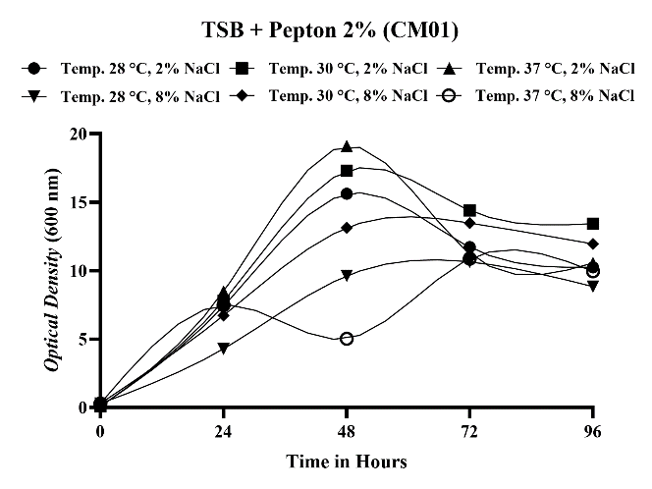a | 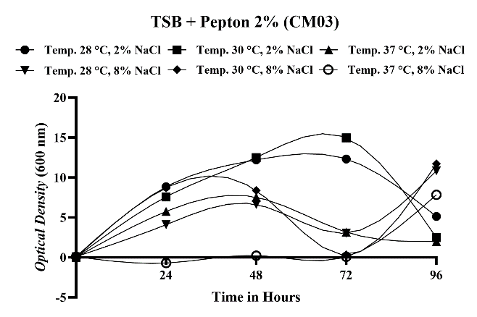d
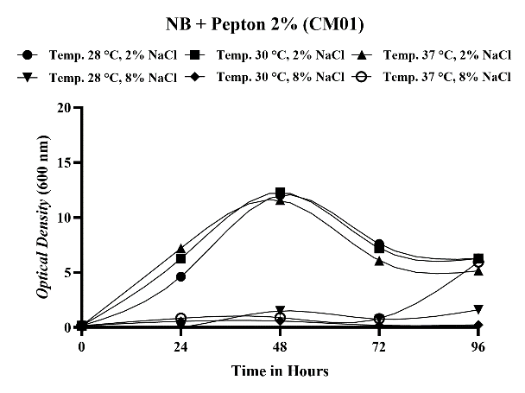b | 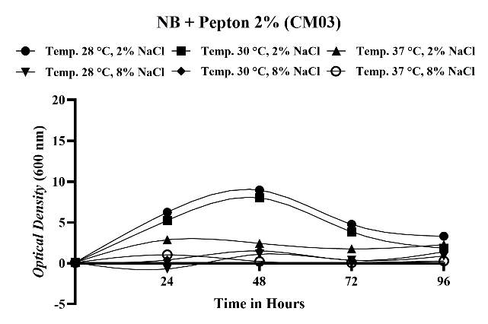e
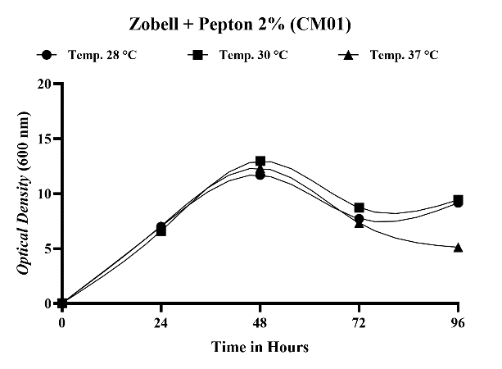c | 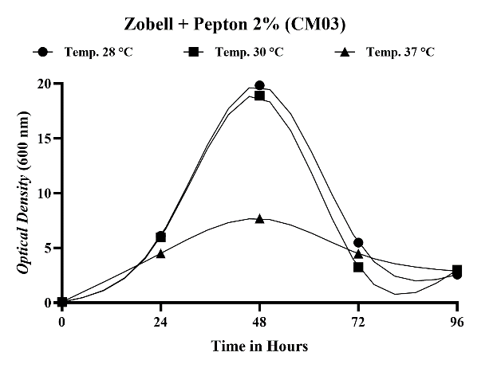f
Figure 1. Growth curves of optimized growth media for marine bacteria (a, b, c) CM01 and (d, e, f) CM03, with TSB medium, 2% peptone, and 2% or 8% NaCl; NB medium, 2% peptone, and 2% or 8% NaCl; and Zobell medium and 2% peptone.

In this study, optimizing growth conditions for marine bacteria is adjusted to the conditions of seawater as their primary habitat. Three mediums were used: NB served as general media, TSB provided richer nutrients, while Zobell medium mimicked marine conditions and required no additional NaCl (Saleem et al., 2024). In this optimization, the addition of peptone inducer enhanced the nitrogen availability (Bonnet et al., 2020). Temperature variations were conducted to adjust to the temperature conditions for marine bacterial species, which generally grow at 28, 30, and 37 °C (Upadhyaya et al., 2024). Incubation was carried out up to 96 hours to achieve optimal growth. Based on the optimization results shown in Figure 1, both CM01 and CM03 grew optimally in TSB medium with 2% NaCl and Zobell medium, respectively, suggesting a preference for moderate salinity (moderate halophilic microorganism).

Antibiofilm Activity
The antibiofilm potential of secondary metabolites derived from marine bacteria was evaluated against five pathogenic strains, namely E. coli, P. aeruginosa, B. subtilis, S. aureus, and S. epidermidis. Not all tested metabolites exhibited significant antibiofilm activity against these pathogens. The 50-hour metabolite of CM01 (Figure 2) demonstrated the highest inhibitory effects against E. coli (84.626 ± 0.906b %), S. epidermidis (70.187 ± 4.291b %), and S. aureus (65.766 ± 37.816a %), at an optimal sampel-to-pathogen ratio of 2:1. However, this metabolite showed negligible inhibition against P. aeruginosa and B. subtilis, with percentage activity below 0 (data not showed). In contrast, the 50-hour metabolite of CM03 (Figure 3) effectively inhibited biofilm formation of E. coli (90.181 ± 0.635a %) and P. aeruginosa (77.508 ± 5.332ab %) at a 2:1 ratio, as well as B. subtilis (59.743 ± 3.657a %) and S. aureus (73.975 ± 7.721b %) at a 1:1 ratio. Biofilm inhibition of S. epidermidis remained limited, with values below 50%.

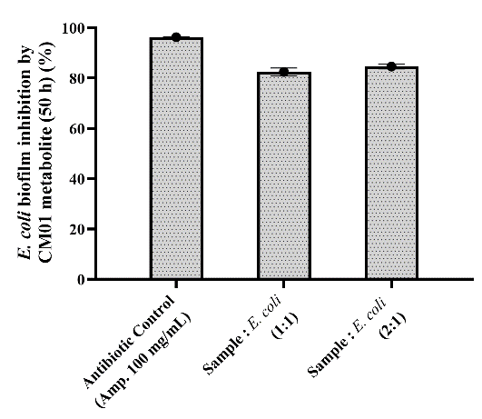a 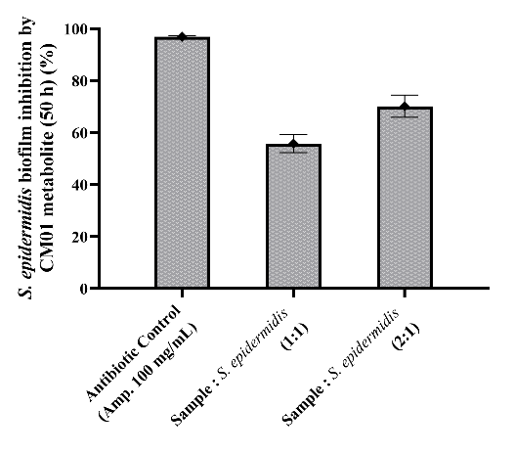b 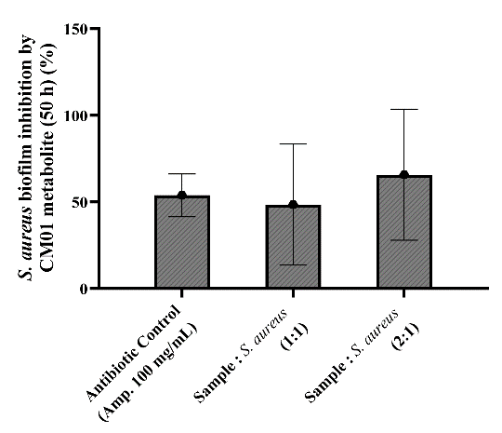c
Figure 2. Effect of the 50-hour metabolites of CM01 against biofilm formation of (a) E. coli, (b) S. epidermidis, and (c) S. aureus with different sample-to-pathogen ratios. Each data point represents the results of three independent experiments, with each experiment conducted in at least triplicate. Error bars indicate the standard deviations of all the measurements. Statistical difference was determined by ANOVA followed by Duncan’s post hoc test at a significance level of p < 0.05.

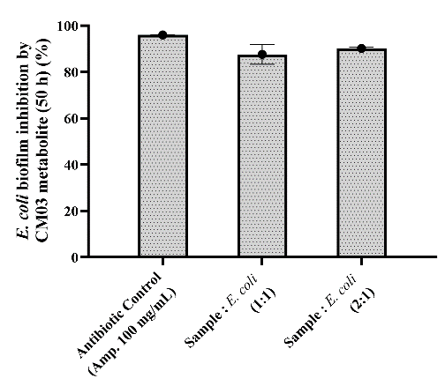a 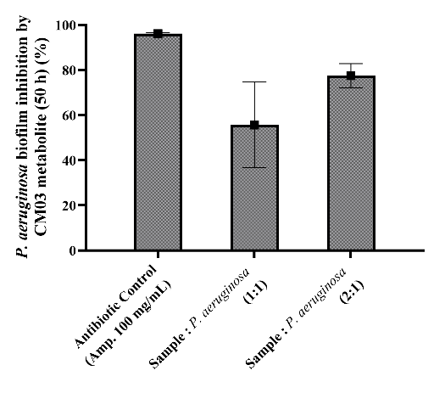b 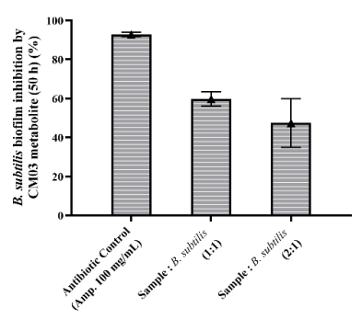c

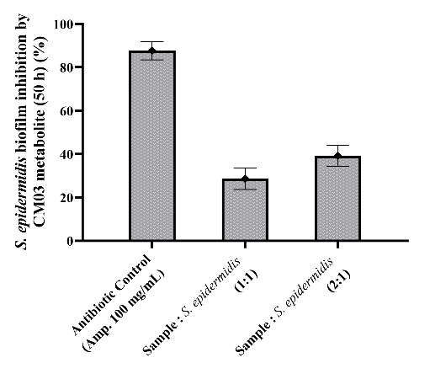d 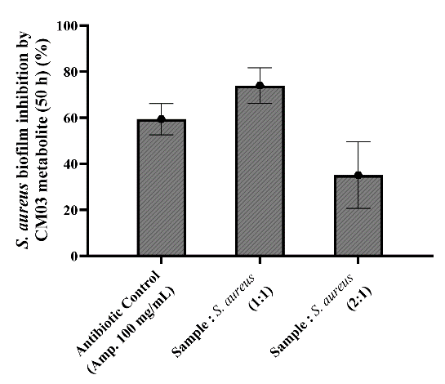e
Figure 3. Effect of the 50-hour metabolites of CM03 against biofilm formation of (a) E. coli, (b) P. aeruginosa, (c) B. subtilis, (d) S. epidermidis, and (e) S. aureus with different sample-to-pathogen ratios. Each data point represents the results of three independent experiments, with each experiment conducted in at least triplicate. Error bars indicate the standard deviations of all the measurements. Statistical difference was determined by ANOVA followed by Duncan’s post hoc test at a significance level of p < 0.05.

Marine-derived bacteria have been acknowledged as an important source of compounds with unique structures and potential bioactivities, including antibiofilm properties against Gram-positive and Gram-negative bacteria (Rizzo et al., 2021). In this study, a total biomass-based assessment using CV was conducted to evaluate the eradication of biofilm formation by the secondary metabolites. As shown in Figures 2 and 3, secondary metabolites from both CM01 and CM03 exhibit diverse and strain-specific antibiofilm activities. The 50-hour metabolite of CM01 showed the strongest antibiofilm effect only against E. coli, S. aureus, and S. epidermidis. Interestingly, this metabolite demonstrated a substantial ability to inhibit S. aureus biofilm formation, which exceeded the inhibition observed for the antibiotic control (Figure 2c). This result suggests that the 50-hour CM01 metabolite holds potential as an antibiofilm candidate against S. aureus, a pathogen recognized for its robust biofilm production and high tolerance to antibiotics. The negligible inhibition observed in P. aeruginosa and B. subtilis indicates that either the metabolite concentration was insufficient, the compound lacks specificity toward the biofilm matrix components, or these species possess more robust extracellular polymeric substance (EPS) structures. P. aeruginosa is specifically known to have a very mature and resistant biofilm system to many antimicrobial compounds, including conventional antibiotics (Liu et al., 2024).
In contrast, the 50-hour metabolite of CM03 demonstrated a broader and stronger antibiofilm potency, particularly against E. coli and P. aeruginosa (Figure 3a and b), with inhibition rates exceeding 75%. This finding is significant because P. aeruginosa is notoriously difficult to target due to its complex biofilm formation and multidrug resistance. The ability of CM03 metabolite to inhibit B. subtilis and S. aureus at a lower sample ratio (Figure 3c and e) suggests higher potency as an antibiofilm agent. Interestingly, increasing metabolite concentrations did not universally enhance antibiofilm activity against pathogens. For CM03, higher concentrations resulted in reduced inhibition against B. subtilis and S. aureus. This pattern may indicate concentration-dependent atagonism, metabolic instability in higher doses, or the presence of compounds that exert inhibitory effects. Similar biphasic responses have been documented in natural metabolites where excessive concentrations may disrupt compound synergy or induce bacterial stress responses that paradoxically promote biofilm formation (Panesyan et al., 2020; Kang et al., 2022).
Taken together, these findings highlight the considerable potential of symbiotic marine bacteria metabolites as sources of antibiofilm compounds. The particularly strong activity observed in the 50-hour metabolite of CM03 makes it promising for further purification, characterization, and analysis of the mechanism of action. Research to identify the specific bioactive molecules, evaluate their cytotoxicity, and explore the synergistic effects with antibiotics need to be conducted.

Visualization of Electrophoresis Results of Genomic DNA Isolation
Based on its strong antibiofilm potential, strain CM03 was subsequently subjected to genomic DNA isolation for molecular diagnosis and taxonomic identification. The electrophoresis method was used to visualize the DNA, enabling separation of nucleic acid fragments according to their size, weight, and molecular conformation. The electropherogram results for CM03 revealed a single, distinct genomic DNA band exceeding the upper range of the 1-kb DNA ladder, with an estimated size greater than 10,000 bp (Figure 4). Thicker and brighter bands correspond to higher DNA concentrations.
(a)
(b)
10.000 bp
> 10.000 bp
Figure 4. Electrophoresis results of amplification of 16S rRNA gene, (a) marker and marine bacteria (b) CM03

Phylogenetic Analysis
The DNA sequences obtained were subjected to sequencing to determine the nucleotide order, which was subsequently queried against the NCBI database, followed by sequence alignment using BioEdit. Phylogenetic trees were then constructed in MEGA11 employing the NJ method with 1,000 bootstrap replicates by comparing the sequences with those of type strains within the genus and an outgroup type strain. Phylogenetic analysis revealed that the isolate clustered tightly with Halalkalibacter okhensis AZMABM_CM03 (accession number PV197611.1 on GenBank) with a bootstrap value of 99% (Figure 5).

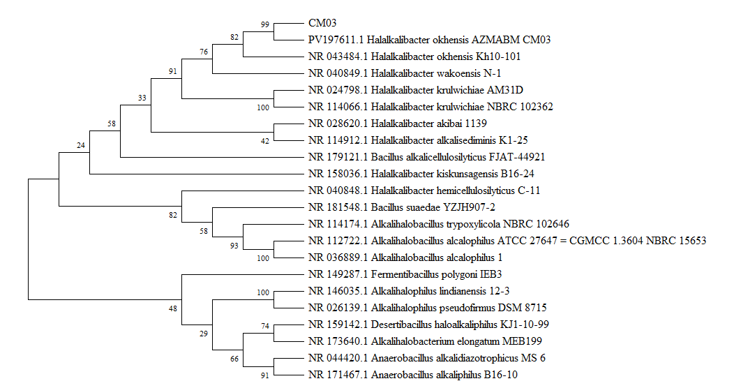
Figure 5. Phylogenetic tree of CM03 based on 16s rRNA gene sequences compared to existing marine bacteria

The genus Halalkalibacter was recently established following the reclassification of Alkalihalobacillus, based on phenotypic characteristics, phylogenetic analysis, and genomic indices (Joshi et al., 2021). Research conducted by Khrisna et al. (2021) demonstrated that the genome of H. okhensis Kh10-101^{T} contains a cluster of ectoine biosynthesis genes. Multiple studies indicate that ectoine contributes to the inhibition of biofilm formation by reducing bacterial adhesion and enhancing surface stability. Its hydration-enhancing effect can reduce the pathogenic bacteria colonization, thereby impeding the initiation of biofilm development. In addition, ectoine exhibits anti-inflamatory properties, which suppress environmental conditions that facilitate biofilm establishment (Bilstein et al., 2021; Simbara et al., 2025). Another study on H. okhensis Kh10-101^{T} reported that this strain also produces a high-alkaline subtilisin (Falkenberg et al., 2022). Subtilisins, a family of alkaline serine endoproteases, have the potential to be used as antimicrobial as well as antibiofilm agents. Recent studies have demonstrated that these enzymes act through degrading adhesion proteins and EPS matrix in E. coli, P. aeruginosa, and S. aureus, resulting in decreased bacterial adherence and interfering with quorum sensing (Gu et al., 2025). Subtilisin also decreases biofilm thickness and disrupts biofilm structural integrity, which enhances antibiotic susceptibility (Liu et al., 2021). Research on catheter-derived P. aeruginosa strain further indicated that subtilisin has potential applications in the management of medical device-associated infections (Kabanov et al., 2019). These findings suggest that marine bacteria, particularly H. okhensis, represent promising sources of antibiofilm compounds.

Conclusions

This study demonstrated that secondary metabolites from symbiotic bacteria from H. magnifica possess antibiofilm activity, which depend on the bacterial strain and the target pathogen. The 50-hour metabolites of CM03, identified as H. okhensis through phylogenetic analysis, exhibit the broadest and most potent inhibitory activity, underscoring their potential as antibiofilm agents.

Conflict of Interest

I have nothing to declare.

Funding

This work was partly supported by DIPA Organisasi Riset Hayati dan Lingkungan, BRIN 2025 (grant numbers RP3.2.13 and RP3.2.3_Batch3).

Author contribution

KS: Writing – original draft, Visualization, Investigation, Formal analysis. EN: Conceptualization, Data curation, Supervision, Funding acquisition, Writing – review & editing. SF: Supervision, Methodology, Data curation.

Acknowledgements

The authors would like to thank A. Zaenal Mustopa (Research Center for Genetic Engineering, BRIN) and A.B. Manguntungi (Universitas Sulawesi Barat) for providing the bacterial samples associated with the H. magnifica, and technical support and facilities from BRIN.

References

Abdillah, L. N., Suryanto, D., Nurtjahja, K., & Mamangkey, J. (2024). Preliminary Study on Potential Bacterial Species Introducing Antibacterial Agent from Sponge in Unggeh Island Central Tapanuli, Indonesia. Jurnal Penelitian Pendidikan IPA, 10(7), 3780–3786. https://doi.org/10.29303/JPPIPA.V10I7.8264
Alencar de Barros, K. M., Sardi, J. de C. O., Maria-Neto, S., Macedo, A. J., Ramalho, S. R., Lourenço de Oliveira, D. G., Pontes, G. S., Weber, S. S., Ramalho de Oliveira, C. F., & Macedo, M. L. R. (2021). A new Kunitz trypsin inhibitor from Erythrina poeppigiana exhibits antimicrobial and antibiofilm properties against bacteria. Biomedicine & Pharmacotherapy, 144, 112198. https://doi.org/10.1016/J.BIOPHA.2021.112198
Andryukov, B., Mikhailov, V., & Besednova, N. (2019). The Biotechnological Potential of Secondary Metabolites from Marine Bacteria. Journal of Marine Science and Engineering, 7(6), 176. https://doi.org/10.3390/JMSE7060176
Bilstein, A., Werkhäuser, N., Rybachuk, A., & Mösges, R. (2021). The effectiveness of the bacteria derived extremolyte ectoine for the treatment of allergic rhinitis. BioMed Research International, 1, 5562623. https://doi.org/10.1155/2021/5562623
Böhringer, N., Fisch, K. M., Schillo, D., Bara, R., Hertzer, C., Grein, F., Eisenbarth, J. H., Kaligis, F., Schneider, T., Wägele, H., König, G. M., & Schäberle, T. F. (2017). Antimicrobial Potential of Bacteria Associated with Marine Sea Slugs from North Sulawesi, Indonesia. Frontiers in Microbiology, 8(JUN). https://doi.org/10.3389/FMICB.2017.01092
Bonnet, M., Lagier, J. C., Raoult, D., & Khelaifia, S. (2020). Bacterial culture through selective and non-selective conditions: the evolution of culture media in clinical microbiology. New Microbes and New Infections, 34, 100622. https://doi.org/10.1016/J.NMNI.2019.100622
Camacho, C., Coulouris, G., Avagyan, V., Ma, N., Papadopoulos, J., Bealer, K., & Madden, T. L. (2009). BLAST+: architecture and applications. BMC Bioinformatics, 10(1), 421. https://doi.org/10.1186/1471-2105-10-421
Falkenberg, F., Rahba, J., Fischer, D., Bott, M., Bongaerts, J., & Siegert, P. (2022). Biochemical characterization of a novel oxidatively stable, halotolerant, and high‐alkaline subtilisin from Alkalihalobacillus okhensis Kh10‐101T. FEBS Open Bio, 12(10), 1729-1746. https://doi.org/10.1002/2211-5463.13457
Gaffney, E. M., Simoska, O., & Minteer, S. D. (2021). The Use of Electroactive Halophilic Bacteria for Improvements and Advancements in Environmental High Saline Biosensing. Biosensors, 11(2), 48. https://doi.org/10.3390/BIOS11020048
Gavriilidou, A., Gutleben, J., Versluis, D., Forgiarini, F., Van Passel, M. W. J., Ingham, C. J., Smidt, H., & Sipkema, D. (2020). Comparative genomic analysis of Flavobacteriaceae: insights into carbohydrate metabolism, gliding motility and secondary metabolite biosynthesis. BMC Genomics, 21(1). https://doi.org/10.1186/S12864-020-06971-7
Gu, N., Dong, Q., Li, H., Liu, X., Wu, H., Zhai, P., ... & Gao, J. (2025). Zirconium-based metal–organic framework immobilized subtilisin for anti-biofilm. Materials Letters, 382, 137818. https://doi.org/10.1016/j.matlet.2024.137818
Hall, A. T. (1999). BioEdit: a user-friendly biological sequence alignment editor and analysis program for Windows 95/98/NT. Nucleic Acids Symposium Series, 41, 95–98.
Haney, E. F., Trimble, M. J., Cheng, J. T., Vallé, Q., & Hancock, R. E. W. (2018). Critical Assessment of Methods to Quantify Biofilm Growth and
Evaluate Antibiofilm Activity of Host Defence Peptides. Biomolecules, 8(2), 29. https://doi.org/10.3390/BIOM8020029
Hassan, S. S. U., & Jin, H. (2024). Harnessing marine bacteria for next-gen antibiotics: potent inhibition of S. aureus and Riemerella anatipestifer through in vitro, omics, and chemoinformatics approach with enhanced production of secondary metabolites through zinc sulfate. Frontiers in Marine Science, 11, 1461607. https://doi.org/10.3389/FMARS.2024.1461607/BIBTEX
Irawan, H., Mustopa, A. Z., Suryadinata, R. P., Manguntungi, A. B., Trinugroho, J. P., Feraliana, Mustafawi, W. Z., ... & Palupi, K. D. (2025). Genome mining identifies Micrococcus yunnanensis strain AZMABM 17 as a potential source of Antioxidant, Anti-Inflammatory, Antidiabetic, and Antiproliferative compounds. Molecular Biology Reports, 52(1), 1-17. https://doi.org/10.1007/S11033-025-11104-Y
Joshi, A., Thite, S., Karodi, P., Joseph, N., & Lodha, T. (2021). Alkalihalobacterium elongatum gen. nov. sp. nov.: An antibiotic-producing bacterium isolated from Lonar Lake and reclassification of the genus Alkalihalobacillus into seven novel genera. Frontiers in Microbiology, 12, 722369. doi: 10.3389/fmicb.2021.722369
Kabanov, D., Khabipova, N., Valeeva, L., Sharipova, M., Rogov, A., Kuznetsova, S., ... & Mardanova, A. (2019). Effect of Subtilisin-like Proteinase of Bacillus pumilus 3–19 on Pseudomonas aeruginosa Biofilms. BioNanoScience, 9(2), 515-520. https://doi.org/10.1007/s12668-019-00617-z
Kang, D., Liu, W., Kakahi, F. B., & Delvigne, F. (2022). Combined utilization of metabolic inhibitors to prevent synergistic multi-species biofilm formation. AMB Express, 12(1), 32. https://doi.org/10.1186/s13568-022-01363-4
Kong, L. S., Islahudin, F., Muthupalaniappen, L., & Chong, W. W. (2021). Knowledge and Expectations on Antibiotic Use Among the General Public in Malaysia: A Nationwide Cross-Sectional Survey. Patient Preference and Adherence, 15, 2405. https://doi.org/10.2147/PPA.S328890
Krishna, P. S., Raghunathan, S., & Prakash, J. S. (2021). Comparative genome analysis of Alkalihalobacillus okhensis Kh10-101 T reveals insights into adaptive mechanisms for halo-alkali tolerance. 3 Biotech, 11(8), 392. https://doi.org/10.1007/s13205-021-02938-x
Kusmiati, K., Fanani, A., Nurkanto, A., Purnaningsih, I., Mamangkey, J., Ramadhani, I., ... & Juanssilfero, A. B. (2024). Profile and in silico analysis of metabolite compounds of the endophytic fungus Alternaria alternata K-10 from Drymoglossum piloselloides as antioxidants and antibacterials. Heliyon, 10(6), e27978. https://doi.org/10.1016/J.HELIYON.2024.E27978
Lee, J.-H., Kim, Y.-G., & Lee, J. (2022). Inhibition of Staphylococcus aureus Biofilm Formation and Virulence Factor Production by Petroselinic Acid and Other Unsaturated C18 Fatty Acids. Microbiology Spectrum, 10(3). https://doi.org/10.1128/SPECTRUM.01330-22
Liu, H. Y., Prentice, E. L., & Webber, M. A. (2024). Mechanisms of antimicrobial resistance in biofilms. Npj Antimicrobials and Resistance, 2(1), 27. https://doi.org/10.1038/s44259-024-00046-3
Liu, J., Madec, J. Y., Bousquet-Mélou, A., Haenni, M., & Ferran, A. A. (2021). Destruction of Staphylococcus aureus biofilms by combining an antibiotic with subtilisin A or calcium gluconate. Scientific Reports, 11(1), 6225. https://doi.org/10.1038/s41598-021-85722-4
Penesyan, A., Paulsen, I. T., Gillings, M. R., Kjelleberg, S., & Manefield, M. J. (2020). Secondary effects of antibiotics on microbial biofilms. Frontiers in Microbiology, 11, 2109. doi: 10.3389/fmicb.2020.02109
Reinl, K. L., Harris, T. D., Elfferich, I., Coker, A., Zhan, Q., De Senerpont Domis, L. N., Morales-Williams, A. M., Bhattacharya, R., Grossart, H. P., North, R. L., & Sweetman, J. N. (2022). The role of organic nutrients in structuring freshwater phytoplankton communities in a rapidly changing world. Water Research, 219. https://doi.org/10.1016/J.WATRES.2022.118573
Rizzo, C., Zammuto, V., Lo Giudice, A., Rizzo, M. G., Spanò, A., Laganà, P., Martinez, M., Guglielmino, S., & Gugliandolo, C. (2021). Antibiofilm Activity of Antarctic Sponge-Associated Bacteria against Pseudomonas aeruginosa and Staphylococcus aureus. Journal of Marine Science and Engineering, 9(3), 243. https://doi.org/10.3390/JMSE9030243
Saleem, A. A., Balakrishnan, G., & Nandhagopal, M. (2024). Secondary Metabolites of Halobacillus sp.: Antimicrobial and Antioxidant Activity, Biological Compatibility, and Gas Chromatography-Mass Spectrometry (GC-MS) Analysis. Cureus, 16(8). https://doi.org/10.7759/CUREUS.67246
Saswita, H. M., Syamsuardi, S., Nurainas, N., Suwardi, A. B., & Taufiq, A. (2023). Phylogenetic Analysis of Baccaurea Spp. in West Sumatra Using MatK Molecular Markers. Biosaintifika: Journal of Biology & Biology Education, 15(3), 362–369. https://doi.org/10.15294/BIOSAINTIFIKA.V15I3.46051
Sharma, S., Mohler, J., Mahajan, S. D., Schwartz, S. A., Bruggemann, L., & Aalinkeel, R. (2023). Microbial Biofilm: A Review on Formation, Infection, Antibiotic Resistance, Control Measures, and Innovative Treatment. Microorganisms, 11(6), 1614. https://doi.org/10.3390/MICROORGANISMS11061614
Tortorella, E., Tedesco, P., Esposito, F. P., January, G. G., Fani, R., Jaspars, M., & De Pascale, D. (2018). Antibiotics from Deep-Sea Microorganisms: Current Discoveries and Perspectives. Marine Drugs, 16(10). https://doi.org/10.3390/MD16100355
Townsley, L., & Shank, E. A. (2017). Natural-product antibiotics: cues for modulating bacterial biofilm formation. Trends in Microbiology, 25(12), 1016-1026.
Tyara Simbara, A., Faridatul Habibah, F., & Hertadi, R. (2025). Rhamnolipid-Modified PHB–Ectoine Nanoparticles for Multifunctional Skin Protection Against UVB, Irritation, and Bacteria. ACS omega, 10(12), 12200-12213. https://doi.org/10.1021/acsomega.4c10583
Upadhyaya, C., Patel, H., Patel, I., Ahir, P., & Upadhyaya, T. (2024). Development of Biological Coating from Novel Halophilic Exopolysaccharide Exerting Shelf-Life-Prolonging and Biocontrol Actions for Post-Harvest Applications. Molecules, 29(3), 695. https://doi.org/10.3390/MOLECULES29030695

